
HSLU
Return Dynamics and Volatility in Bitcoin and the S&P 500
An ARIMA-GARCH Approach
Ibtihel Frini
22/05/2026

Table of Contents
Introduction 2
Literature Review and Theoretical Background 2
Methodology and Hypotheses 3
Results and Discussion 4
Conclusion 6
References 6

Figure 1: logarithmic return formula 3
Figure 2: Bitcoin and S&P 500 Log Returns 4
Figure 3: Conditional volatility comparison between Bitcoin and the S&P 500 (2018–2026) 5

Introduction
Financial markets are characterized by dynamic behavior, uncertainty, and periods of heightened volatility. Understanding the statistical properties of financial time series is therefore essential for risk management, portfolio allocation, and forecasting. In particular, asset returns often exhibit stylized facts such as stationarity, volatility clustering, and limited linear predictability, which cannot be captured by simple models.
In recent years, the emergence of cryptocurrencies, particularly Bitcoin, has introduced a new dimension to financial markets. Unlike traditional assets such as equity indices, Bitcoin is decentralized, highly speculative, and subject to rapid price fluctuations. At the same time, the S&P 500 index represents a broad measure of the U.S. equity market and reflects macroeconomic conditions and investor sentiment. Comparing these two assets provides valuable insights into differences and similarities between traditional and alternative financial markets.
This study aims to analyze and compare the return dynamics and volatility behavior of Bitcoin and the S&P 500 using time series methods. Specifically, autoregressive integrated moving average (ARIMA) models are employed to capture the dynamics of returns, while generalized autoregressive conditional heteroskedasticity (GARCH) models are used to model time-varying volatility. By applying these models, the study investigates whether both assets exhibit similar statistical properties and whether their volatility patterns show signs of interconnected behavior.
The contribution of this paper lies in providing a comparative empirical analysis of a traditional financial index and a cryptocurrency using established time series techniques. The findings offer insights into the nature of financial market behavior and contribute to the understanding of volatility dynamics across different asset classes.

Literature Review and Theoretical Background
Financial time series have been extensively studied in the literature, particularly due to their unique statistical properties. One of the most well-known stylized facts is that asset returns are typically stationary, while price levels are not. In addition, financial returns often exhibit little to no autocorrelation, suggesting limited linear predictability, but display significant volatility clustering, where periods of high volatility tend to be followed by further high volatility.
To model the dynamics of financial time series, autoregressive integrated moving average (ARIMA) models are widely used. These models capture linear dependencies in the mean of a time series by combining autoregressive (AR) and moving average (MA) components. Despite their usefulness, ARIMA models assume constant variance and therefore cannot account for time-varying volatility observed in financial markets.
To address this limitation, Engle (1982) introduced the autoregressive conditional heteroskedasticity (ARCH) model, which allows the variance of a time series to depend on past squared errors. This approach was later extended by Bollerslev (1986) into the generalized ARCH (GARCH) model, which incorporates both lagged squared residuals and lagged variances. The GARCH(1,1) specification has become a standard model in financial econometrics due to its ability to capture volatility clustering and persistence effectively.
Empirical studies have shown that financial markets often exhibit high volatility persistence, where shocks to volatility decay slowly over time. This phenomenon is particularly pronounced in emerging and speculative markets such as cryptocurrencies. At the same time, traditional financial indices such as the S&P 500 tend to exhibit more stable behavior, although they are still subject to significant fluctuations during periods of economic stress.
This study builds on the existing literature by applying ARIMA and GARCH models to both Bitcoin and the S&P 500, allowing for a comparative analysis of return dynamics and volatility behavior across different types of financial assets.

Methodology and Hypotheses
This study employs a quantitative time series approach to analyze and compare the return dynamics and volatility behavior of Bitcoin and the S&P 500. Daily closing price data for both assets were obtained from Yahoo Finance, covering the period from January 2018 onward. To ensure consistency in the analysis, the Bitcoin and S&P 500 return series were aligned using common trading dates, and missing observations were removed.
Since financial time series models are typically applied to returns rather than prices, the data were transformed into continuously compounded returns using the logarithmic return formula:
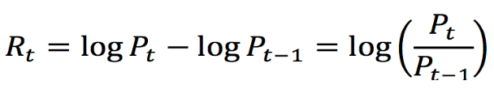
Figure 1: logarithmic return formula
where P_{t} represents the closing price at time t. This transformation stabilizes the variance and ensures stationarity under typical market conditions.
The analysis proceeds in several steps. First, a visual inspection of the return series is conducted to identify general patterns such as volatility clustering. Second, stationarity is formally tested using the Augmented Dickey-Fuller (ADF) test. Third, autocorrelation and partial autocorrelation functions (ACF and PACF) are examined to assess the presence of linear dependencies in the data.
To model the return dynamics, ARIMA models are estimated for both time series using an automatic selection procedure based on information criteria. These models capture any remaining linear structure in the mean process. Residual diagnostics, including the Ljung-Box test, are then performed to verify that the models adequately remove autocorrelation.
To model time-varying volatility, GARCH(1,1) models are applied to both return series. This specification allows the conditional variance to depend on both past squared residuals and past variances, capturing the persistence of volatility commonly observed in financial markets. The estimated parameters are used to assess volatility clustering and persistence.
Finally, the conditional volatilities extracted from the GARCH models are compared to evaluate similarities and differences in volatility behavior between Bitcoin and the S&P 500. To further investigate possible interconnectedness between both markets, a Vector Autoregression (VAR) framework is applied to the estimated volatility series, followed by Granger causality tests to examine whether volatility in one market contains predictive information about future volatility in the other market.
Based on this framework, the following hypotheses are tested:
- H1: Bitcoin and S&P 500 returns are stationary after transformation into log returns.
- H2: Both return series exhibit volatility clustering.
- H3: ARIMA models adequately capture the return dynamics of both series.
- H4: GARCH models provide an appropriate representation of time-varying volatility in both markets.
- H5: Bitcoin and S&P 500 volatility exhibit statistically significant predictive interdependence.

Results and Discussion
The empirical analysis begins with a visual inspection of the return series for both Bitcoin and the S&P 500. The plots indicate that both series fluctuate around zero, confirming the absence of a deterministic trend. However, clear differences in volatility can be observed. Bitcoin exhibits significantly larger fluctuations, with frequent and pronounced spikes, while the S&P 500 shows comparatively smaller and more stable movements. In both cases, periods of high volatility tend to cluster together, providing initial evidence of volatility clustering.
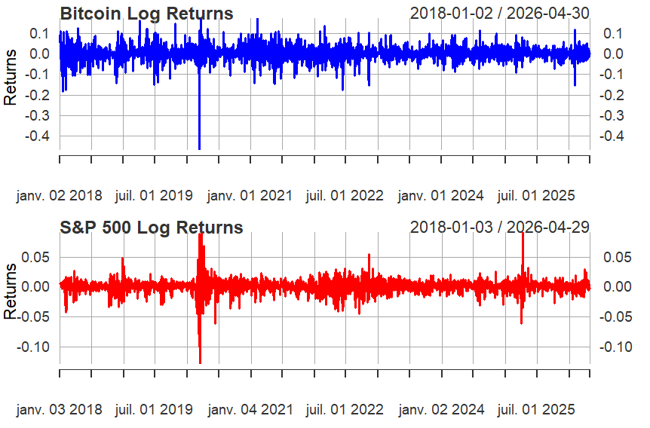
Figure 2: Bitcoin and S&P 500 Log Returns
The results of the Augmented Dickey-Fuller test confirm that both return series are stationary, with p-values below 0.01. This supports the first hypothesis and validates the use of time series models that assume stationarity.
The analysis of autocorrelation and partial autocorrelation functions reveals that most coefficients lie within the confidence bounds, indicating weak serial dependence in both series. This suggests that returns are largely unpredictable in a linear sense, which is consistent with the efficient market hypothesis.
ARIMA models were estimated to capture any remaining linear structure in the data. For Bitcoin, an ARIMA(5,0,1) model was selected, while for the S&P 500, an ARIMA(4,0,4) model provided the best fit according to information criteria. Residual diagnostics using the Ljung-Box test indicate that both models adequately removed autocorrelation from the residuals (p > 0.05), confirming that the models successfully capture the mean dynamics of both return series.
The estimated GARCH parameters indicate strong volatility persistence in both markets. Bitcoin exhibits near-unit volatility persistence, with the sum of the ARCH and GARCH parameters (α + β) reaching approximately 0.999, suggesting that volatility shocks decay extremely slowly over time. The S&P 500 also demonstrates high persistence (α + β ≈ 0.962), although volatility shocks dissipate somewhat faster compared to Bitcoin. These findings confirm the presence of substantial volatility clustering in both markets.
The estimated conditional volatilities reveal clear structural differences between both markets. Bitcoin exhibits a consistently higher baseline level of volatility throughout the sample period, reflecting its speculative nature and heightened sensitivity to market uncertainty. In contrast, the S&P 500 maintains substantially lower average volatility levels but experiences short-lived and pronounced spikes during periods of market stress, particularly around major macroeconomic or financial events. Although the volatility series do not always move synchronously, both exhibit clear volatility clustering and persistence over time.
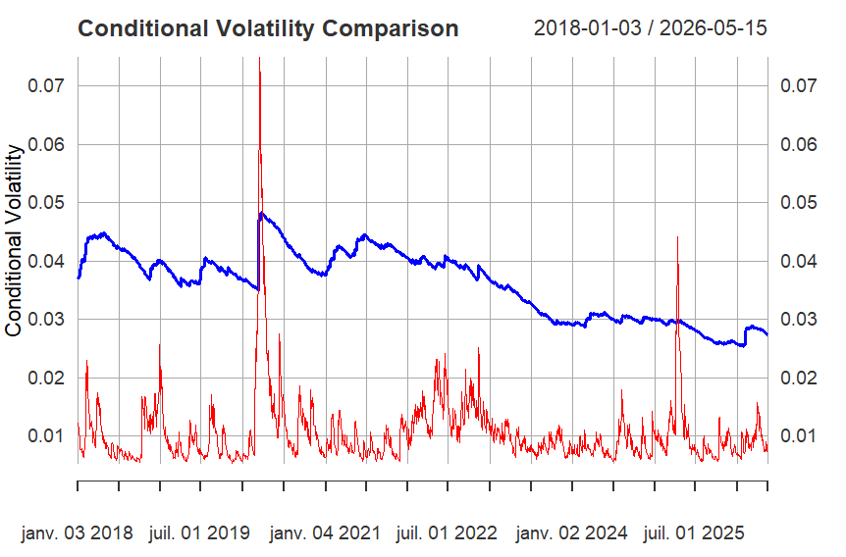
Figure 3: Conditional volatility comparison between Bitcoin and the S&P 500 (2018–2026)
To further investigate the relationship between the two markets, a Granger causality test was conducted on the estimated conditional volatility series. The results indicate statistically significant bidirectional causality between Bitcoin and S&P 500 volatility (p < 0.01). This suggests that past volatility in one market contains predictive information about future volatility in the other. In addition, the presence of significant instantaneous causality indicates that both markets respond simultaneously to common external shocks. These findings provide stronger evidence of interconnected behavior between cryptocurrency and traditional financial markets. As an additional robustness check, a GARCH-X specification was also explored following feedback. However, the exogenous volatility coefficients were not statistically significant, so the main interpretation is based on the VAR and Granger causality results.

Conclusion
This study examined the return dynamics and volatility behavior of Bitcoin and the S&P 500 using ARIMA and GARCH models. The results confirm that both return series are stationary and exhibit limited linear predictability, which is consistent with established findings in financial time series analysis.
Despite the weak autocorrelation in returns, both assets display strong volatility clustering. The GARCH(1,1) models provide a good fit for the data and reveal a high degree of volatility persistence in both markets. In particular, the sum of the estimated parameters is close to one, indicating that shocks to volatility decay slowly over time.
Bitcoin exhibits a persistently higher volatility level and stronger volatility persistence, reflecting its speculative nature and sensitivity to market uncertainty. In contrast, the S&P 500 is relatively more stable but still responds to market shocks, especially during periods of economic stress.
The volatility analysis highlights important structural differences between both markets. Bitcoin exhibits persistently elevated volatility over the entire sample period, whereas the S&P 500 maintains lower average volatility but experiences sharp temporary spikes during periods of market stress. Despite these distinct volatility profiles, the VAR-based Granger causality analysis provides strong evidence of bidirectional volatility spillovers between both markets, indicating increasing interconnectedness between cryptocurrency and traditional equity markets.
Overall, the findings demonstrate the usefulness of ARIMA and GARCH models in capturing the key characteristics of financial time series. Future research could extend this analysis by applying multivariate models to better capture potential spillover effects or by incorporating additional asset classes.

References
Engle, R. F. (1982). Autoregressive conditional heteroskedasticity with estimates of the variance of United Kingdom inflation. Econometrica, 50(4), 987–1007.
Bollerslev, T. (1986). Generalized autoregressive conditional heteroskedasticity. Journal of Econometrics, 31(3), 307–327.
Box, G. E. P., Jenkins, G. M., Reinsel, G. C., & Ljung, G. M. (2015). Time series analysis: Forecasting and control (5th ed.). Wiley.
Tsay, R. S. (2010). Analysis of financial time series (3rd ed.). Wiley.

